1. **What is software? What is software engineering?**

Ans: Software is a set of instruction, data, or programs that computers use to perform specific task

Software engineering is a branch of computer science that involves designing, developing, testing and maintaining software applications

1. **Explain types of software.**

Ans: The two main categories of software are application software and system software

An application software is software that fulfils a specific need or perform tasks system software is designed to run a computers hardware and provide a platform for applications to run on top of.

1. **What is SDLC? Explain each phase of SDLC**.

Ans : The software development life cycle is project management model that describes the process of creating software from its initial idea to its final deployment and maintenance it’s structured methodology with clearly defined processes to help create high-quality software, The SDLC has seven phases:

Planning :Also known as the feasibility phase, this is when developers understand products scope, purpose and what stakeholders want.

Design :This phase defines how the software will work by choosing a programming language

Implementation :This phase is when engineers transform the pre-approved architecture into a functional system it includes code writing and testing

Testing :This phase ensures the software’s functionality and quality at each development stage

Deployment :This phase is when the software is pushed from the development environment usually an app store

Maintenance :This phase is when the developed product is updated based on changing user needs or technology

1. What is DFD? Create a DFD diagram on Flipkart.

Ans : A data flow diagram(DFD) is visual representation of how data moves through a system or process. DFDs can be used to analyze existing systems or model new ones.

Add to cart

Product

Liked by byer

Send request

For order

Bye After confirmation

Order confirm

Buy now

Payment confirmation

1. **What is Flow chart? Create a flowchart to make addition of two numbers.**

Ans : A flowchart is diagram that shows the steps sequence and decision in a process or workflow. It’s versatile tool that can be used in many different scenarios, such as : Documenting and standardizing processes visualizing complex ideas and systems making data-driven decisions, identifying and preventing bottlenecks and planning and tracking project progress.

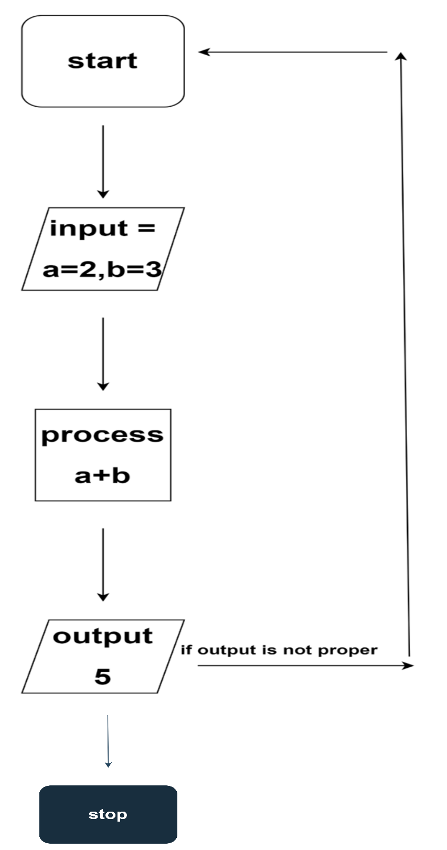

1. **What is Use case Diagram? Create a use-case on bill payment on pay tm.**

Ans : A use case diagram is visual representation of how a user inter acts with a system, It’s high level overview that shows the relationships between users ,actors, and systems. Use case diagram are used in the unified modelling language(UML)

User Admin